**WEEK 1 – GitHub and IntelliJ**

1. **What is the use of the git add command?**

The git add command is used to stage changes in the working directory for the next commit. It tells Git to include updates to a particular file (or all files) in the next commit.

Ex: git add file.txt (specific file)

Ex: git add . (all files in current directory)

1. **Write the command to create a branch “feature-group”.**

git branch feature-group

OR

git checkout -b feature-group

1. **What is a pull request? Write the steps involved in creating a pull request.**

A pull request (PR) is a request to merge changes from one branch (usually a feature branch) into another branch (usually the main or develop branch) in a remote repository, often used for code review and collaboration.

Steps to create a Pull Request:

1. Create a new branch: git checkout -b feature-branch
2. Make changes and commit them.
3. Push the branch to the remote repository: git push origin feature-branch
4. Go to the repository on GitHub.
5. Click on the "Compare & pull request" button.
6. Add a title, description, and reviewers if needed.
7. Click on "Create pull request".
8. **How do you add collaborators?**

Steps to add collabotators:

1. Go to the repository page.
2. Click on Settings > Collaborators
3. Click on "Add people".
4. Enter the GitHub username or email of the collaborator.
5. Click "Add".
6. **What is the command used to commit our changes in github repo?**

To commit changes locally: git commit -m "Your commit message"

1. **Create a github account and repository to save all your assignment tasks. Example repository name: rg-assignments.**

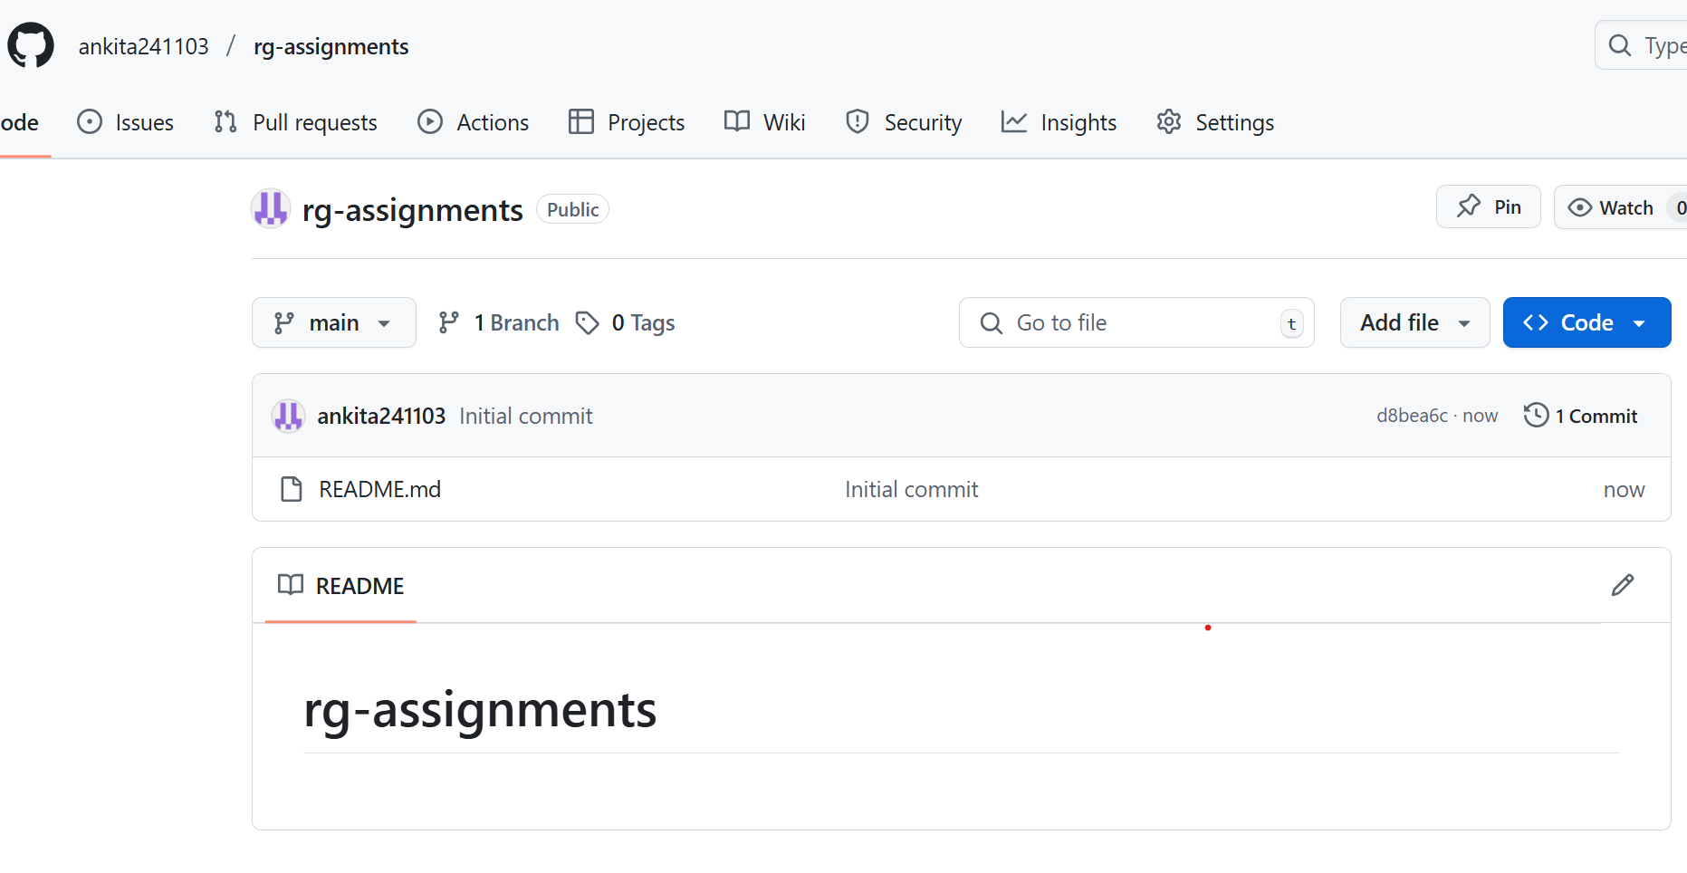

1. 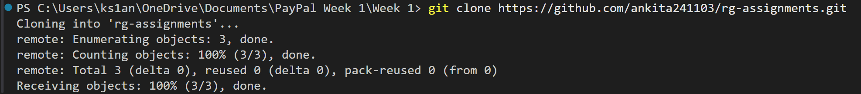**Create a branch called feature-java**

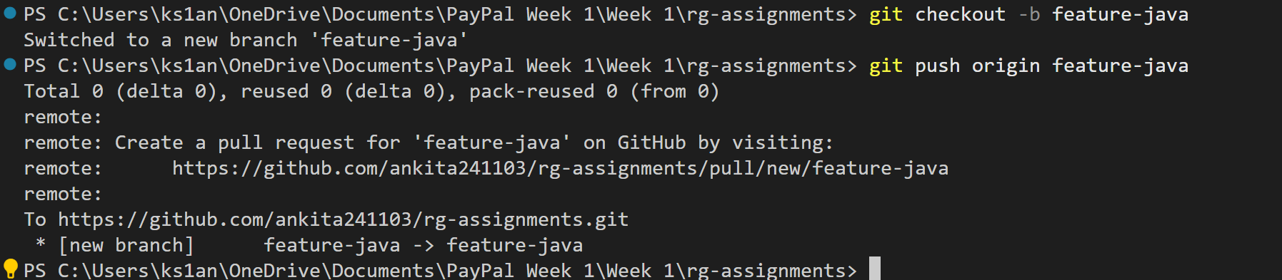

1. **Install IntelliJ IDE. Create a simple java project displaying “Hello World!!”and share the screenshot.**

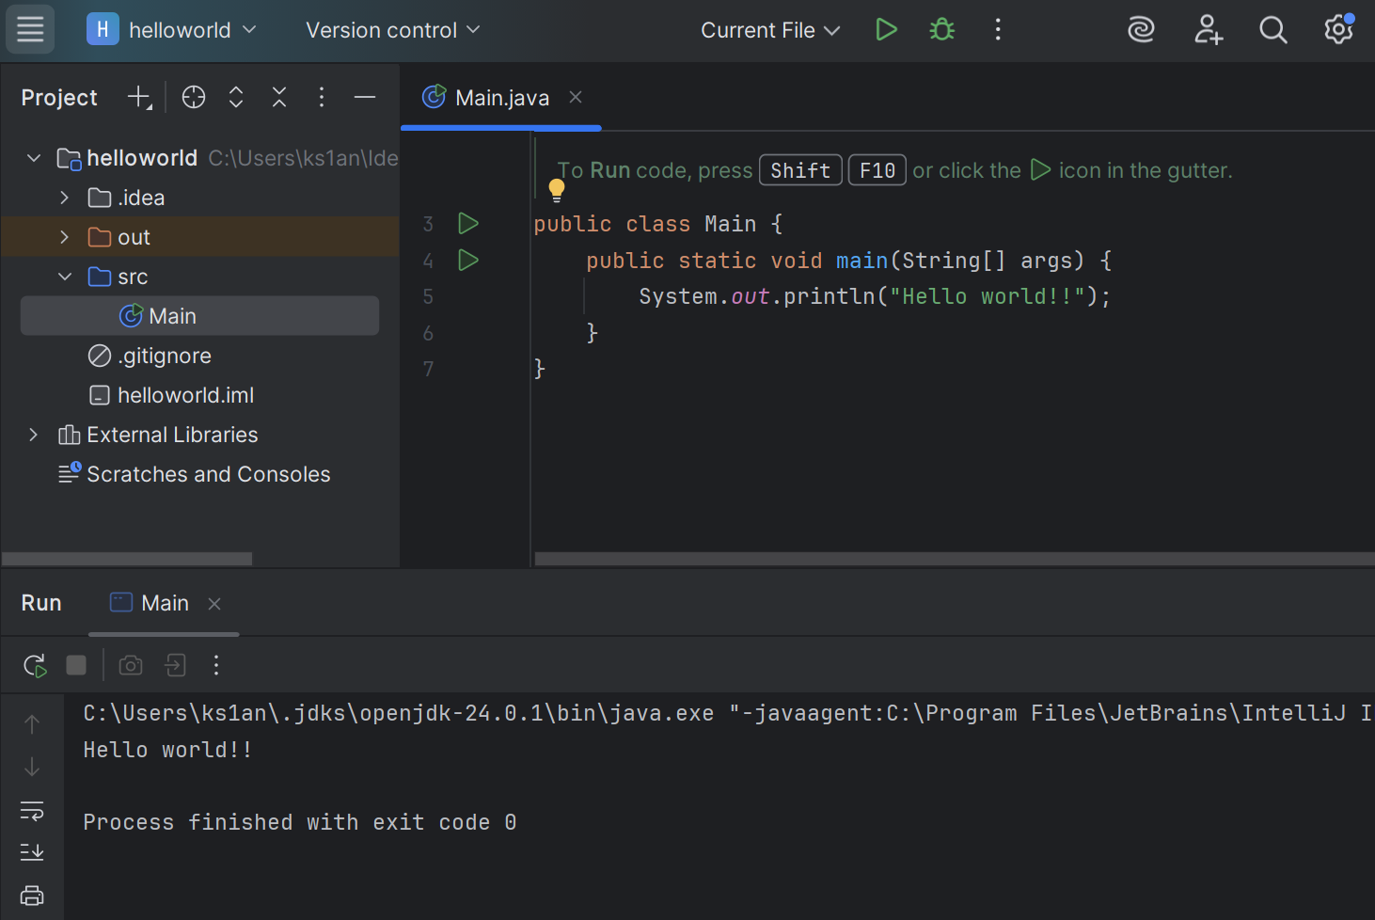

1. **In IntelliJ IDE, explore the shortcut keys for the following**

**a. To run the project:** Shift + F10

**b. To select a line:** Ctrl + W

**c. To comment/uncomment a line:** Ctrl + /

**d. To delete a line:** Ctrl + Y